Usability Evaluation

Introduction:
This report evaluates the usability of the old and redesigned versions of the game Clash Royale to identify improvements in efficiency, effectiveness, and user satisfaction.

Redesigns:
- Result Screen
Before:
- Match results provided limited visual feedback.
- Rewards and statistics were not clearly highlighted.
- Weak visual hierarchy made important information harder to notice.
- Screen lacked engagement and excitement after gameplay.

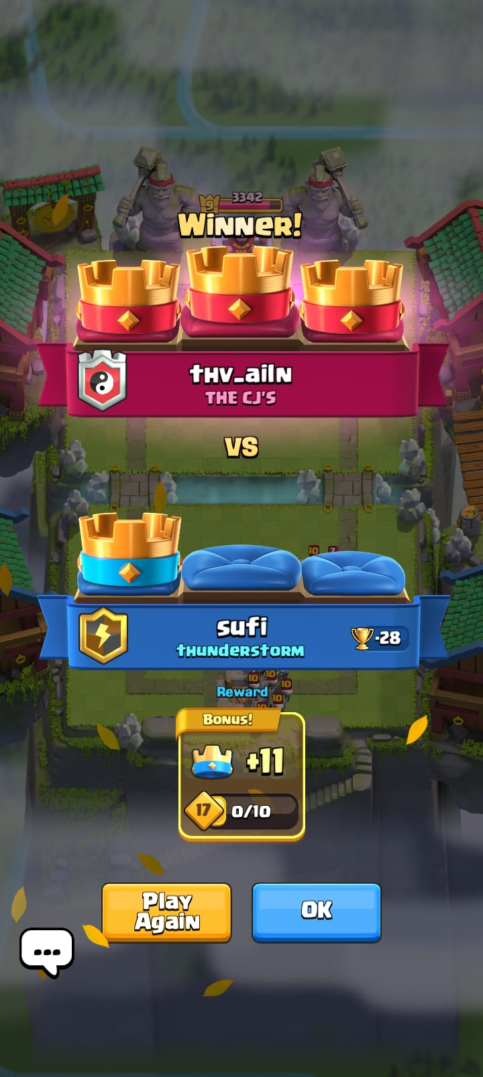
After:
- Result screen redesigned with stronger visual emphasis on Victory/Defeat.
- Rewards, trophies, and statistics are clearly organized.
- Improved typography and spacing increase readability.
- Better feedback system enhances user satisfaction and engagement.
- Clear action buttons allow users to continue smoothly to the next task.
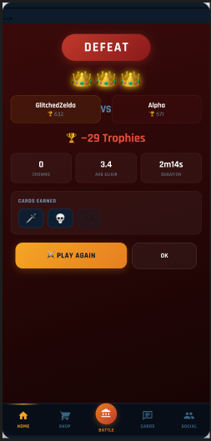

- Setting Screen
Before:
- Basic layout with limited structure
- Poor grouping
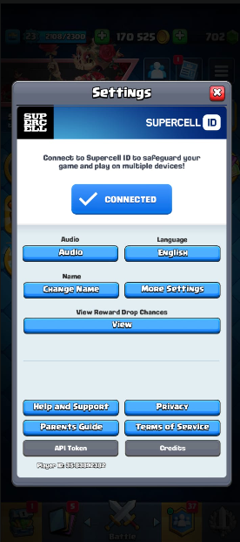

After:

  - Categorized Settings
  - Toggle switches for clarity
  - Better readability and organization
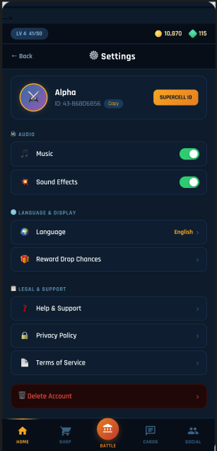

- Deck / Collection Screen
Before:
- Crowded card layout
- Hard to scan
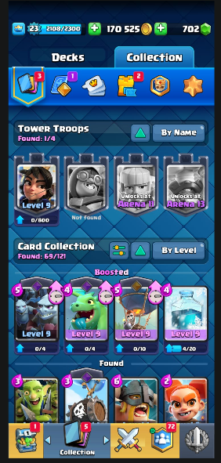

After:
- Grid-based structured layout
- Clear card separation
- Easier selection and engagement
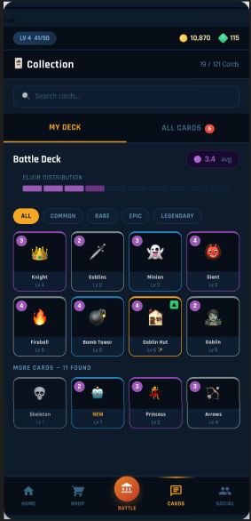

- Gameplay UHD
Before:
- Gameplay interface had limited spacing between controls.
- Card and elixir information could become visually crowded during battles.
- Important gameplay information was not clearly prioritized.
- Some controls lacked visibility during intense gameplay.
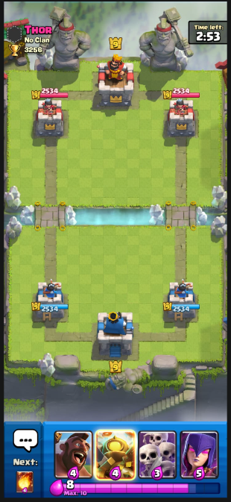
After:
- Gameplay HUD redesigned with a cleaner and more balanced layout.
- Improved spacing makes cards and controls easier to access.
- Elixir bar and gameplay indicators are more visible.
- Better visual hierarchy helps players focus during battles.
• Enhanced readability improves reaction time and gameplay experience.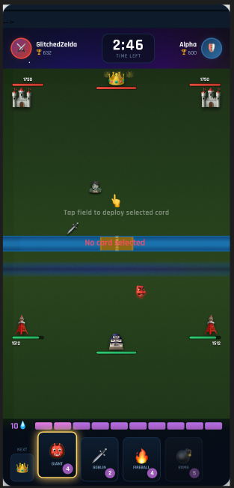

- Main Menu
Before:
- Main menu contained too many elements on a single screen.
- Important features such as Battle, Events, and Rewards competed for attention.
- Poor spacing created a cluttered appearance.
- Navigation options were not clearly grouped.
- Users could become overwhelmed, especially new players.
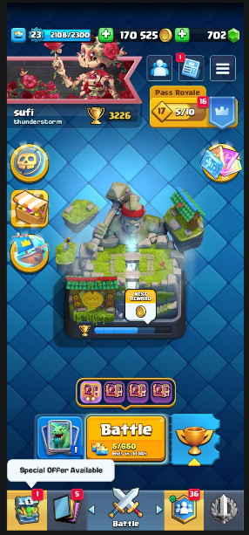
After:
- Main menu redesigned with a cleaner and more organized structure.
- Large centered Battle button improves visibility of the primary action.
- Features are grouped into clear sections for easier navigation.
- Improved spacing and alignment reduce visual clutter.
- Consistent icons and layout improve usability and accessibility.
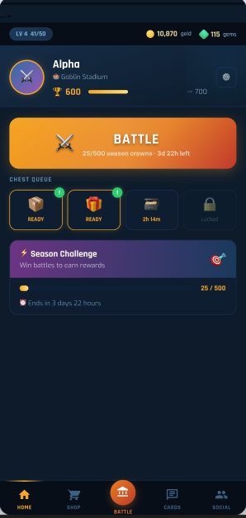
- Shop
Before:
- Offers and shop items were displayed in a cluttered vertical layout.
- Different offer categories were not clearly separated.
- Clicking on offers opened crowded sections with too much information at once.
- Users had difficulty distinguishing between special offers, gems, and card packs.
- Poor organization increased cognitive load.

After:
- Shop redesigned using a card-style layout for better readability.
- Offers are grouped into clear categories (Special Offers, Gems, Cards, Pass Royale).
- Clicking an offer opens a clean dedicated section with focused information.
- Improved spacing and visual hierarchy help users quickly identify important deals.
- Easier navigation reduces confusion and improves shopping experience.
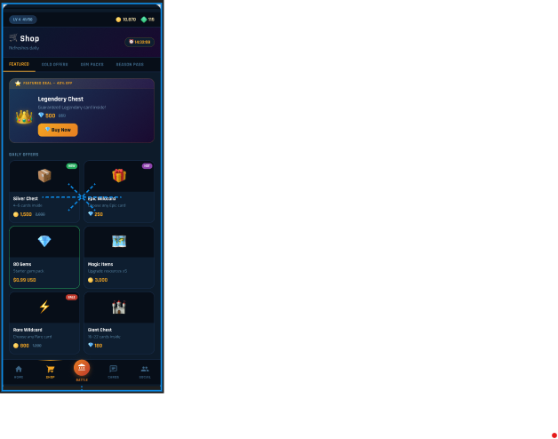
- Social Screen
Before:

- Social and clan features were mixed together in a crowded interface.
- Friend list was difficult to scan due to poor spacing and small icons.
- Important actions such as Invite, Chat, and View Profile were not clearly visible.
- Navigation between clan chat, friends, and team requests required extra steps.
- Lack of visual hierarchy caused confusion for users.
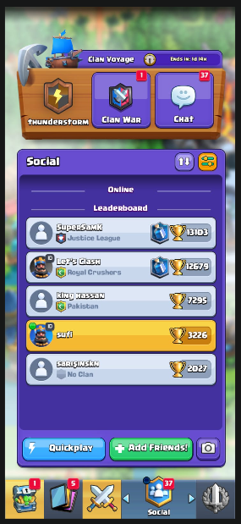

After:
- Structured with clear friend’s list and actions
- Social screen redesigned with a clean and organized layout.
- Friend list displayed using separated cards for better readability.
- Clear action buttons added for Invite, Message, and Profile Access.
- Improved spacing and alignment reduce clutter and cognitive load.
- Navigation between friends, and requests is faster and more intuitive.
- Consistent design and color scheme improve overall user experience.
